**Virtualisation & Cloud Computing**

**Assignment # 01**

* **By**

**Mandar Bhalerao (M23CSA025)**

**GitHub URL :** [**https://github.com/m23csa025/VCC-Assignments/tree/VCC-Asgnmt-%2301**](https://github.com/m23csa025/VCC-Assignments/tree/VCC-Asgnmt-%2301)

**Google Drive URL :** [**https://drive.google.com/drive/folders/1PnbE63E62Yb32XuncrSQosxQcpS0dJqJ?usp=share_link**](https://drive.google.com/drive/folders/1PnbE63E62Yb32XuncrSQosxQcpS0dJqJ?usp=share_link)

**Question :**

**Objective:**

**Create and configure multiple Virtual Machines (VMs) using VirtualBox, establish a network between them, and deploy a microservice-based application across the connected VMs.**

**Deliverables:**

**1. Document Report:**

**Step-by-Step Instructions for Implementation:**

**Installation of VirtualBox and creation of multiple VMs.**

**Configuration of network settings to connect the VMs.**

**Deployment of a simple microservice application (e.g., a RESTful API or a Node.js-based service)**

**across the VMs.**

**2. Architecture Design:**

**Diagram showing the connection of VMs and their roles in hosting the microservice application.**

**3. Link to Source Code Repo:**

**GitHub or similar repository containing the source code of the microservice application and**

**deployment configuration.**

**4. Link to Recorded Video Demo:**

**A video demonstrating the creation, configuration, and hosting process with a voice-over**

**explanation.**

**Solution :**

1. My laptop configuration : Macbook Air (M2) 8 GB 512 GB

2. Virtualbox is not fully compatible with macbook.

3. Search for alternative which is available for free, in app store or is reliable.

4. Possible options : 1. **Universal Turing Machine (UTM)**

**-** App Store (Paid version)

- Website (free version) <https://mac.getutm.app/>

- Reliable

2. **Parallels Desktop**

- App store (free)

5. Chose UTM based on reviews and star ratings.

6. Downloaded UTM and Installed in Macbook.

7. **Choice of VM Environment**

1. ARM version
2. Choice between Ubuntu/ Linux/Windows/MacOS and various other versions available on UTM
3. I chose Debian 12 which is a version of Linux for ease of operation on macbook

8. Download Debian 12 from website <http://cdimage.debian.org/>

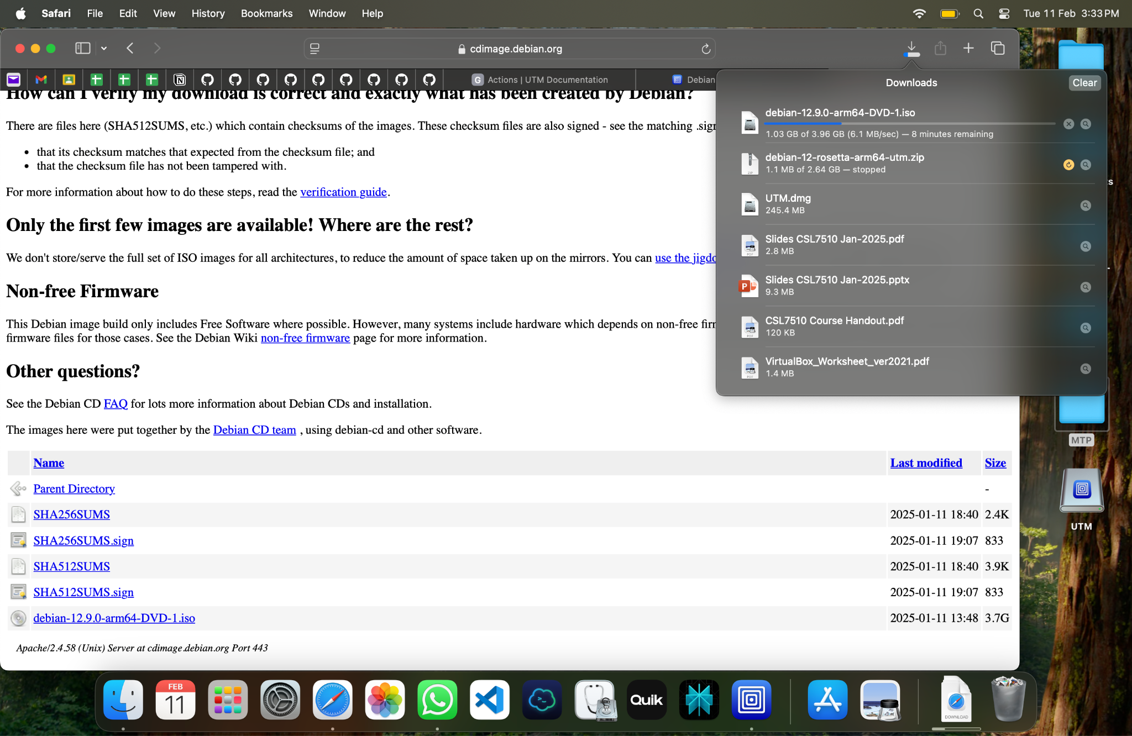

9. Open UTM. Install and configure **vm1**.

RAM - 4 GB

HDD - 20 GB

Debian Desktop Environment

GNOME

User : mandar

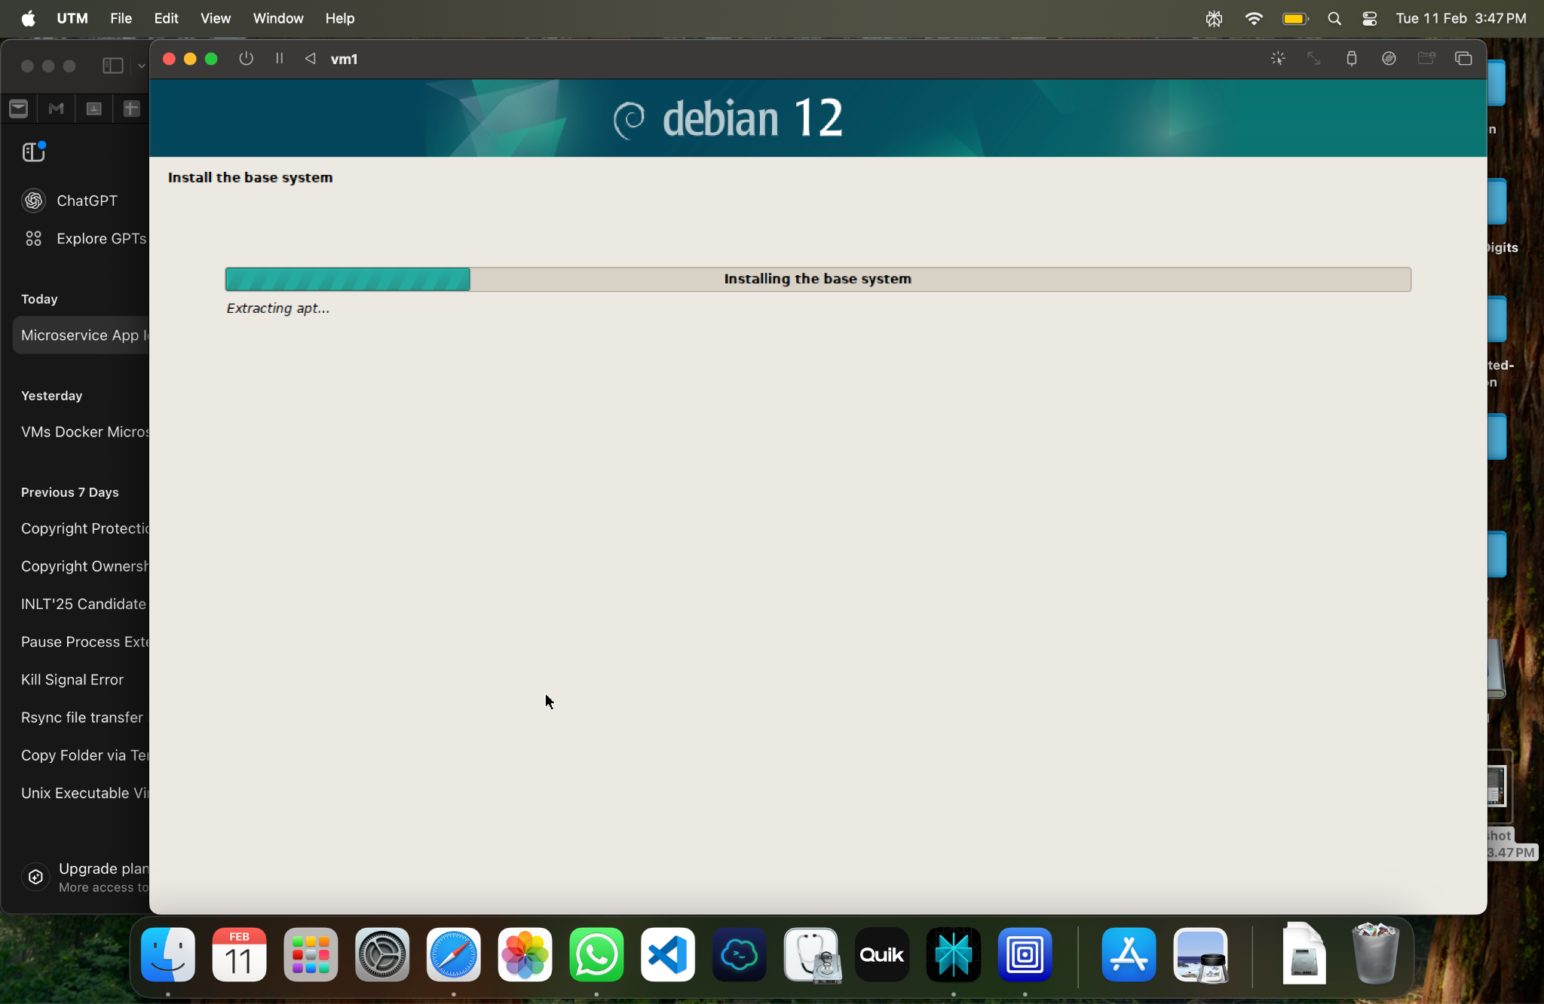

10. Install and configure **vm2.**

RAM - 4 GB

HDD - 20 GB

Debian Desktop Environment

GNOME

User : mandar1

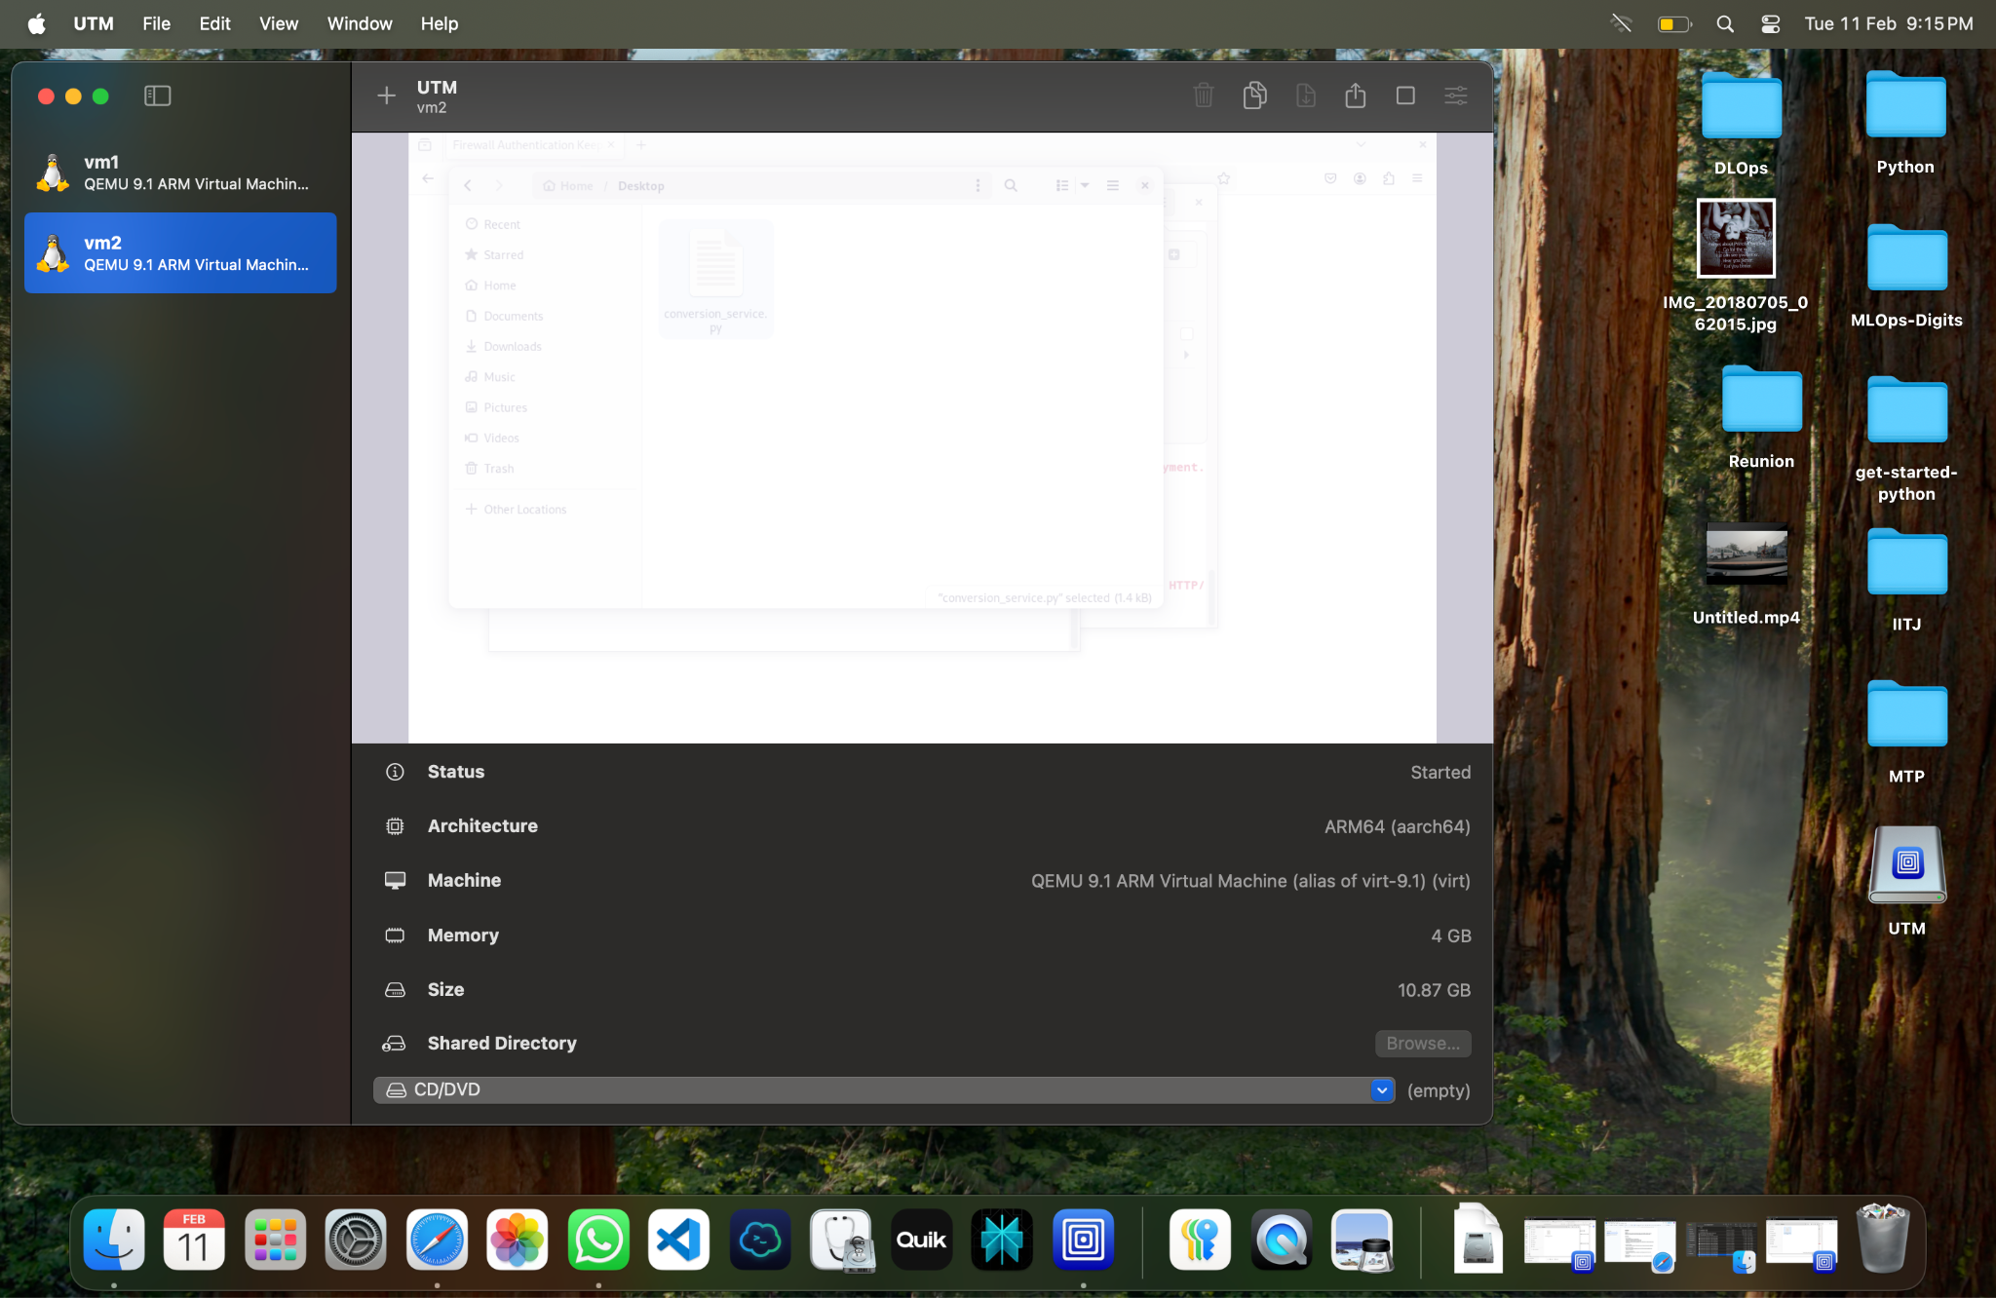

11. Configure networking in vm1 & vm2.

1. Disable wifi
2. Connect to wired LAN/Network
3. Configure / Auto Configure IP address.
4. IP for vm1 : 10.6.1.43
5. IP for vm2 : 10.6.1.44

12. Run ping micro service.

1. On vm1 : ping 10.6.1.44
2. On vm2 : ping 10.6.1.43
3. **Successful ping on both VMs.**
4. Screen shots enclosed.

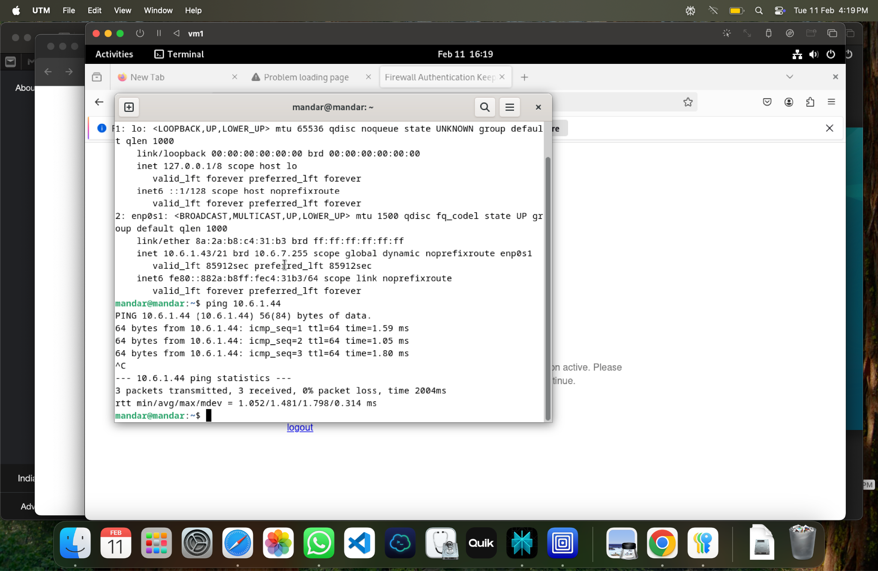

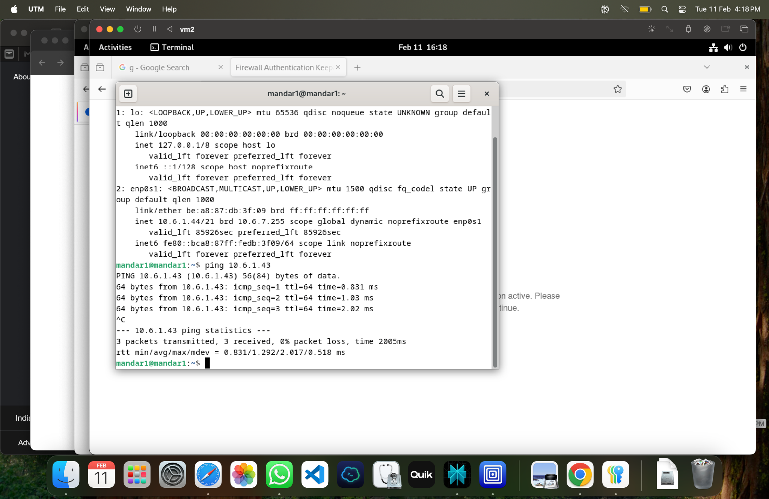

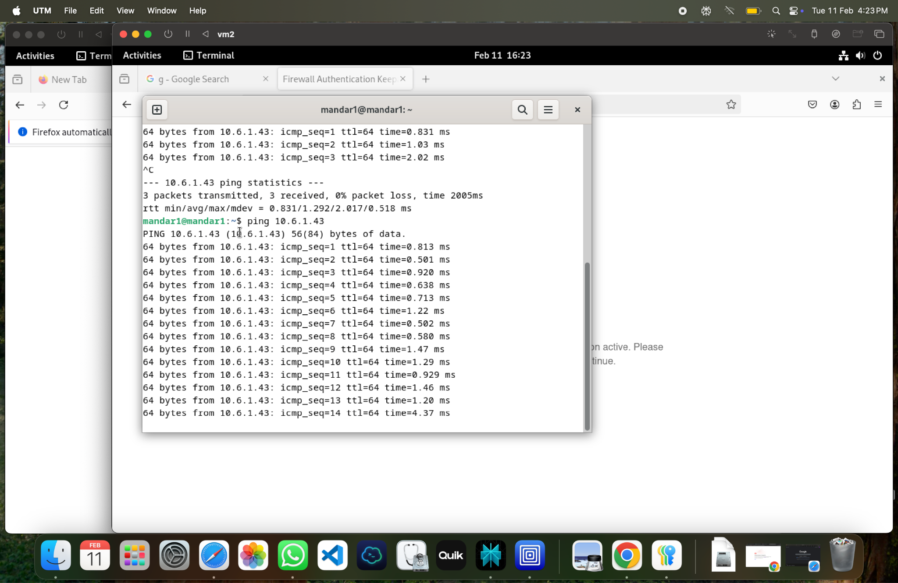

13. **Currency Conversion Service**.

This service consists of two microservices:

**a. Exchange Service (VM1)** – Provides exchange rates for different currencies and allows updating rates.

**Functionality**

The Exchange Service manages currency exchange rates. It has two key

Endpoints:

* **GET /rate/<currency>**: Retrieves the exchange rate for a given currency.
* **POST /rate**: Updates the exchange rate for a specified currency.

Maintains an in-memory dictionary for exchange rates (exchange_rates).

Handles both retrieval and update of exchange rates.

Returns appropriate HTTP status codes and error messages.

**b. Conversion Service (VM2)** – Uses the Exchange Service to convert an amount from one currency to another.

**Functionality** The Conversion Service converts a given amount from one currency to another

using the Exchange Service for rate information. It has one main endpoint:

* **POST /convert**:  
  Converts an amount from one currency to another.

Sends GET requests to the Exchange Service for both source and target

Currencies.

Calculates the converted amount based on the retrieved rates.

Handles errors such as missing parameters or invalid currencies.

c. Install relevant python and Flask.

d. Save exchange.py (vm1) and conversion.py (vm2) on desktop of respective VMs.

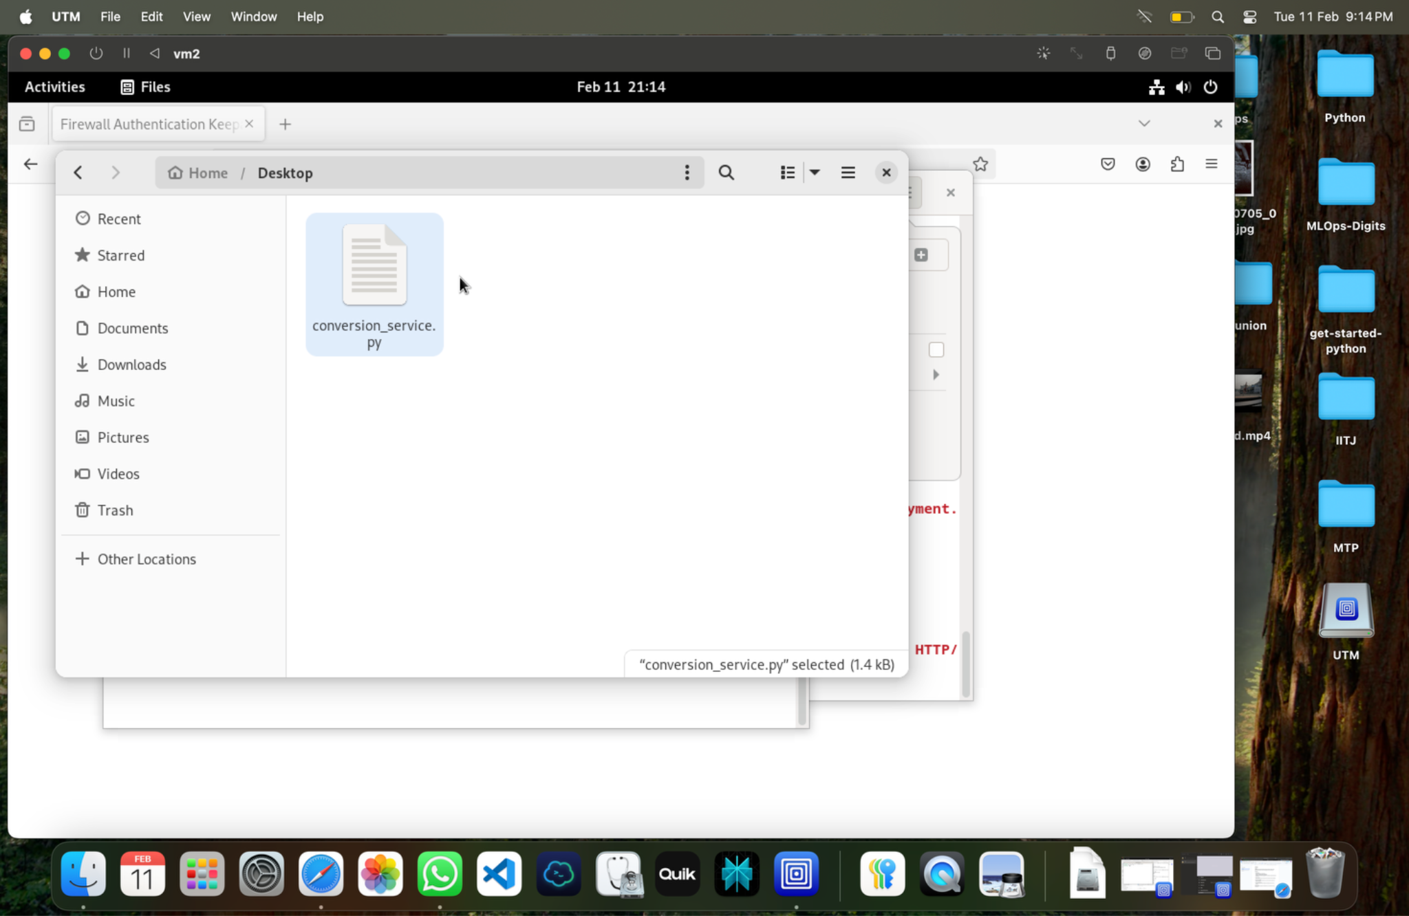

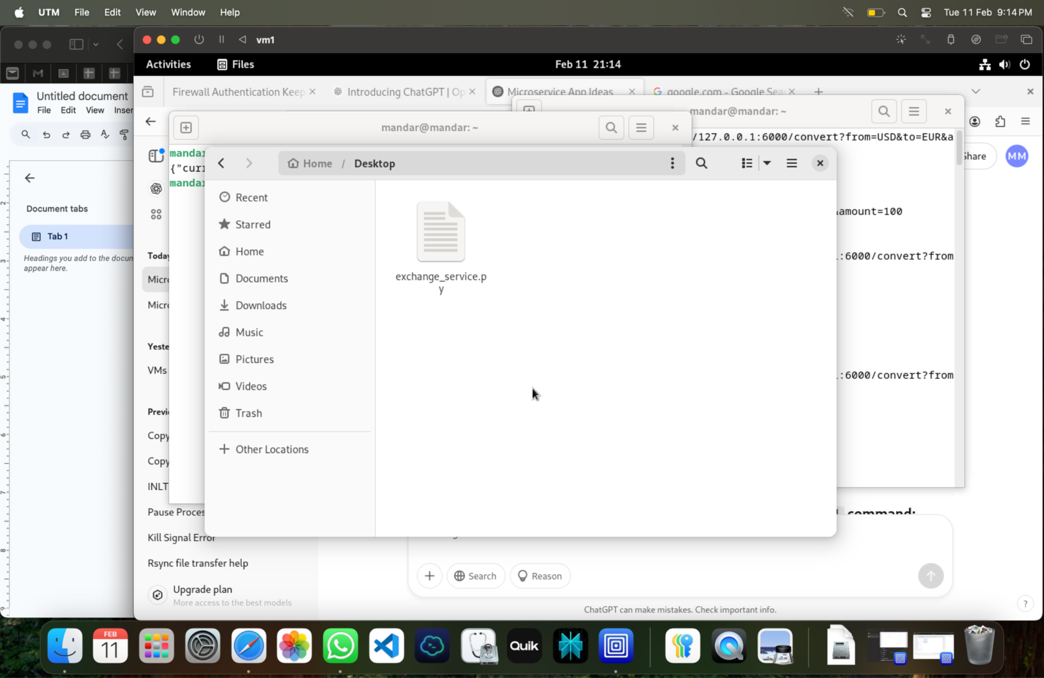

e. Activate and run both microservices.

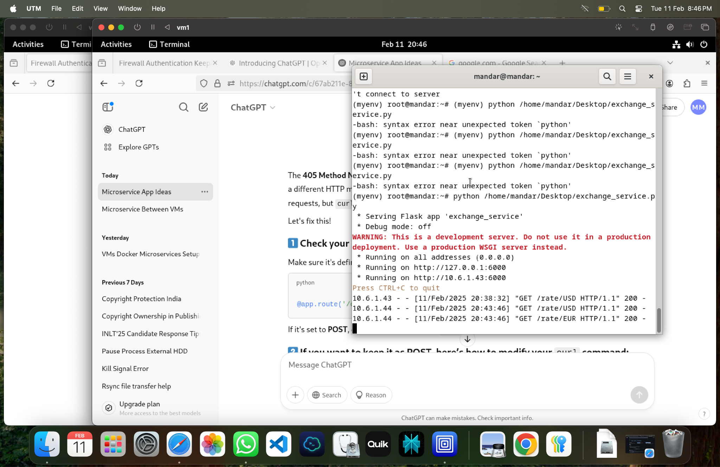

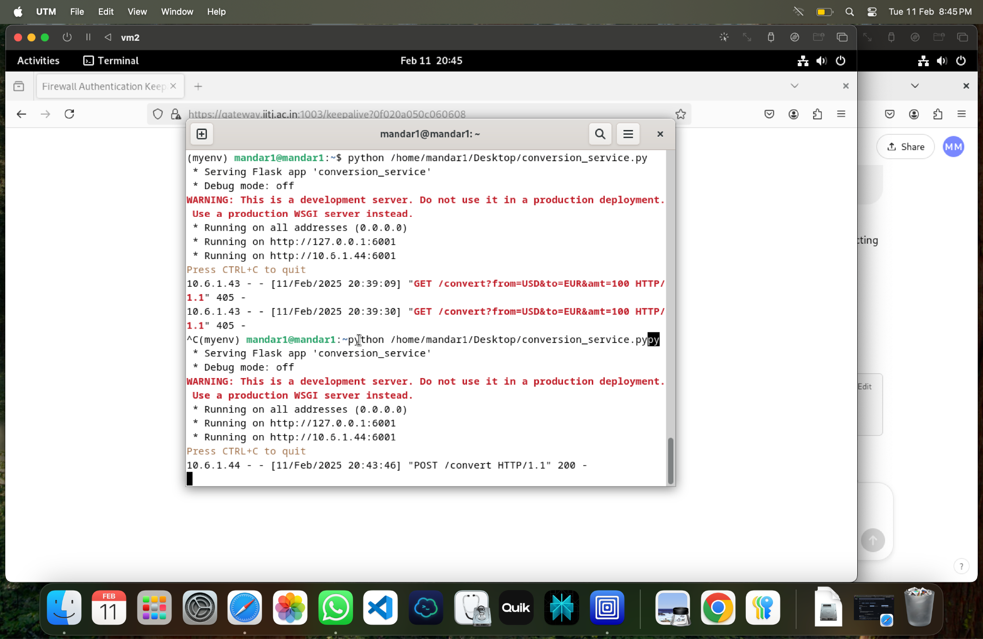

**f. Testing and Validation :**

Check for connection between two VMs using ping again .

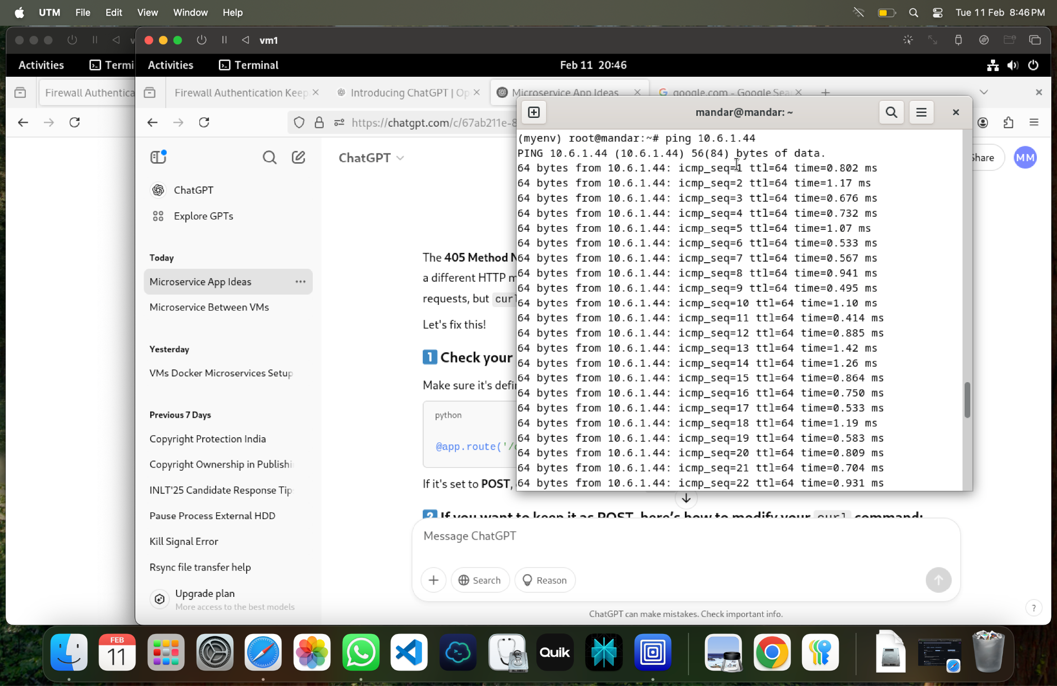

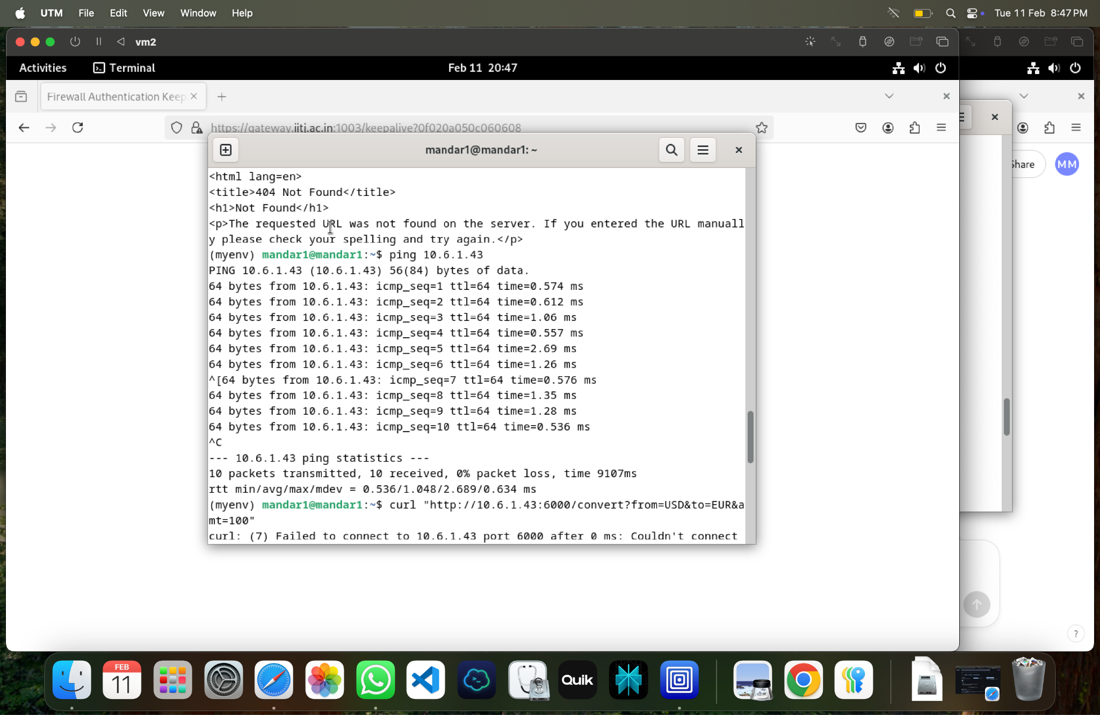

g. Check functionality of exchange service on vm1.

curl "http://10.6.1.43:6000/rate/USD"

Expected Response :

{"currency":"USD","rate":1.0}

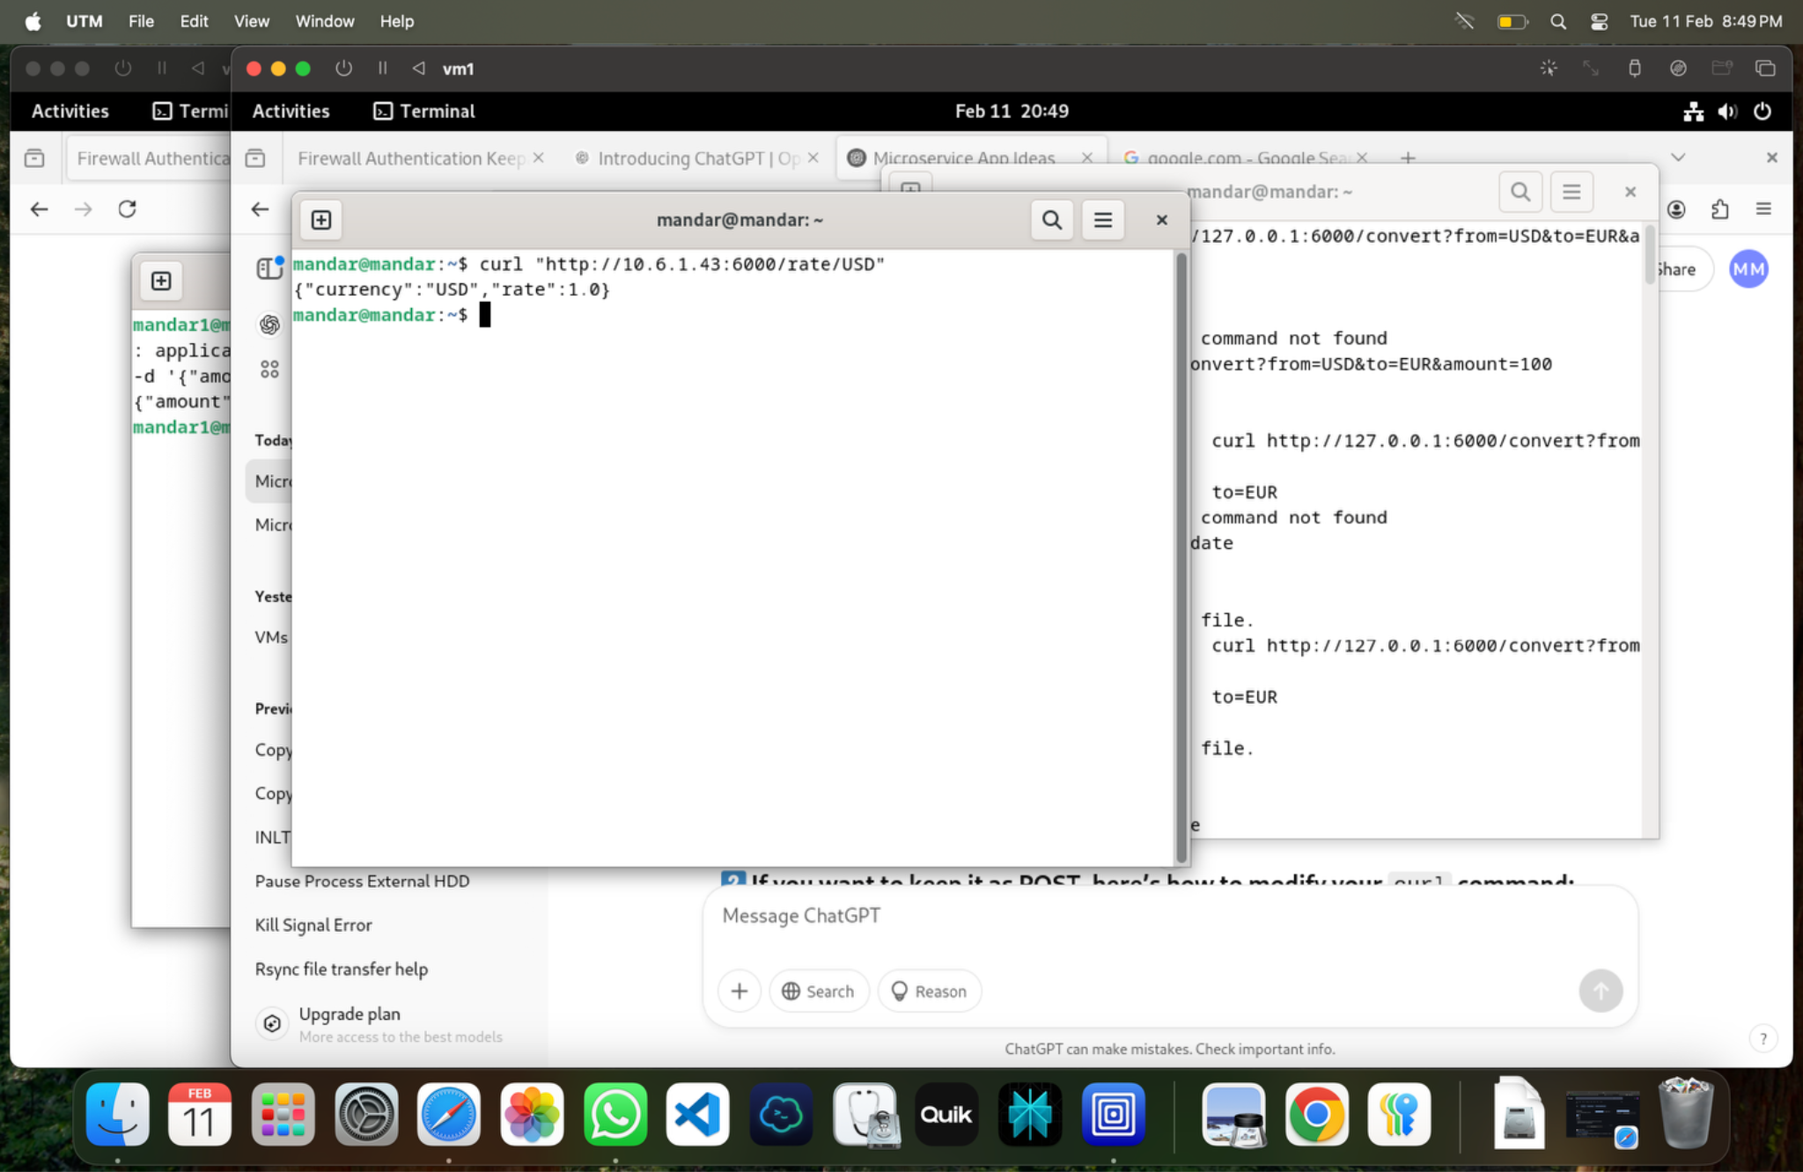

h. Check functionality of conversion service on vm2.

curl -X POST "http://10.6.1.44:6001/convert" -H "Content-Type: application/json" \

-d '{"amount": 100, "from_currency": "USD", "to_currency": "EUR"}'

Expected Response :

{

"from_currency": "USD",

"to_currency": "EUR",

"amount": 100,

"converted_amount": 85.0

}

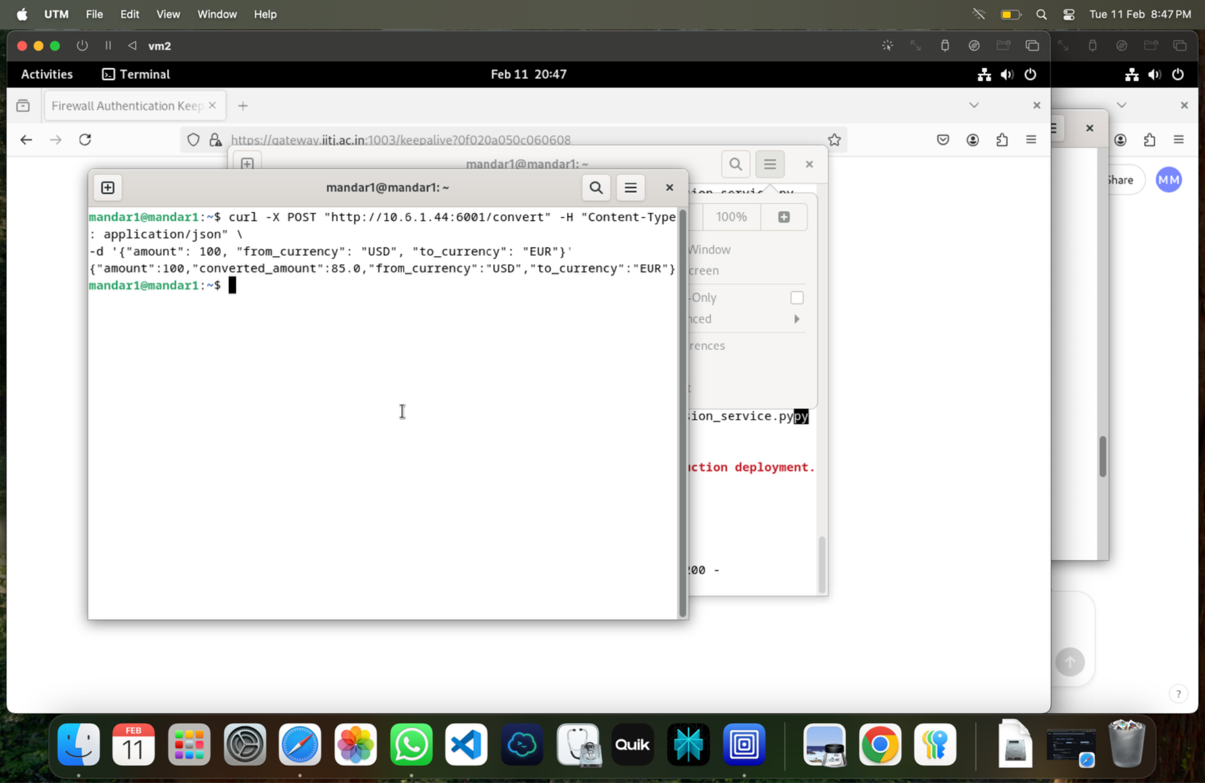

**Conclusion :**

Currency conversion micro services successfully implemented on vm1 & vm2.